

**Mahatma Gandhi Mission’s College of Engineering & Technology**

Kamothe,Navi Mumbai – 400 209

Department of Computer Engineering

Academic Year :2015-16

A Project Report On

**Web Technology**

Submitted By

Mr. Prasad Sawant

Mr. Nitin Sawant

Mr. Shaikh Haamid

Under The Guidance Of

DR. ANITHA PATIL

Presenting Project Report On

LIBRARY MANAGEMENT SYSTEM

Department Head Principal

Dr.Anitha Patil Dr. S. K. Narayankhedkar

**CERTIFICATE**

This is to certify that the project work entitled

“**ONLINE LIBRARY MANAGEMENT**”

done by “ Mr. Prasad Sawant, Mr. Nitin Sawant , Mr. Shaikh Haamid student of **Department of Computer Science Engineering** , is a record of bonafide work carried out by them. This project is done as a partial fulfillment of obtaining **Bachelor of Engineering** Degree to be awarded by **MAHATMA GANDHI MISSION OF TECHNOLOGY,NAVI MUMBAI.**

**ACKNOWLEDEMENT**

We would like to express our heartfelt thanks to all those who have helped us in making this report a success. However, it would not have been possible without the kind support and help of many individuals. We would like to extend our sincere thanks to all of them.

We are highly indebted to DR.ANITHA PATIL for his guidance and constant supervision as well as to all the staff members of Computer Dept. and lab facilities by which we have enlighten on topics regarding our report.

Our thanks and appreciations also go to our colleagues in developing the report and people who have willingly helped us out with their abilities.

**ABSTRACT**

The project on web technology titled as “ONLINE LIBRARY MANAGEMENT SYSTEM” describes a complete registration.

The OnlineLibrary Management System project is made computerized to reduce human made errors and to increase the efficiency. The main aim of this library management system projectis to reduce human efforts. The maintenance of the records is made easy and all the records are stored in the Sql database which can be retrieved easily afterwords. Suitable navigation control is given in all the forms to navigate through the records in this project.

|  |  |  |
| --- | --- | --- |
| **TABLE OF CONTENTS** | | |
| **SR.NO** | **TOPIC** | **PAGE NO.** |
| **1.** | INTRODUCTION  1.1 Objective of the project | 1  2 |
| **2.** | SYSTEM ANALYSIS  2.1. System study and analysis  2.2. Existing system  2.3. Proposed system  2.4. Feasibility study  2.5. System specification  2.5.1. Software requirements  2.5.2. Hardware requirements  2.6. Tools / Platforms | 3 |
| **3.** | SYSTEM DESIGN  3.1. Input design  3.2. Database Design | 4 |
| **4.** | DESCRIPTION OF PROJECT  4.1. Working of the system  4.2. Data flow diagrams | 6 |
| **5.** | TESTING | 8 |
| **6.** | IMPLEMENTATION | 22 |
| **7.** | CONCLUSION AND FUTURE SCOPE | 32 |
| **8.** | BIBLIOGRAPHY |  |

The matter embodied in this project report has not been submitted to any other university for the award of any other degree.

**DR.ANITHA PATIL DR.ANITHA PATIL**

**( INTERNAL GUIDE) HEAD Dept of CSE**

1. **INTRODUCTION:**

“ONLINE LIBRARY MANAGEMENT SYSTEM” is a software developed for managing various activities in the library. Borrowing books, returning books or viewing the available books at the Library of the local University is currently done manually where in the student has to go to the Library and check the available books at the Library. Students check the list of books available and borrow the books if the book is a borrow book otherwise it is of waste for the student to come to the library to come to check for the books if the student doesn’t get the book. Then the librarian checks the student id and allows the member to check out the book and the librarian then updates the member database and also the books database. This takes at least one to two hours if the member is available at the near by place otherwise it may take more time.

We have decided to investigate the use of an Online Library Management System. This system would be used by members who may be students or professors of that University to check the availability of the books and borrow the books, and by the librarian to update the databases. The purpose of this document is to analyze and elaborate on the high-level needs and features of the *Online Library Management System***.** It focuses on the capabilities and facilities provided by a Library. The details of what all are the needs of the *Online Library Management System* and if it fulfils these needs are detailed in the use-case and supplementary specifications

**1.1. Objective of the project:**

* It is more time saving when we do it through computerization.
* It reduces the wastage of man power.
* It leads to the automation and accuracy of reports generated.
* Less money required.
* It allows operator to view at any time ‘availability of room’.
* Operator (Librarian) can view the status andinformaitonof the student.
* Automate the fine generation course wise.

1. **System analysis:**
   1. **System study and analysis:**

A feasibility study was conducted to select the best system that meets performance requirements and this was entailed an identification description, an evaluation of candidate systems, and the selection of the best systems.

In deciding on this system to design, three key considerations are involved in feasibility analysis: technical, economical and operation. It was found that the proposed system is technically, economically and operationally feasible as per following grounds:

* The system was developed using PHP and Java Script.
* The site was developed with Windows as operating system.
* The site is interactive. (Its user friendly, thus viewing information and the related features is easy.)
* Easy retrieval and access of data is provided.
  1. **Existing system:**
* It is more time consuming as all the work is done manually.
* It requires more of paper work to be done.
* It requires lot of capital because more number of employees are hired for job.
* It does not have accuracy and consistency in work.
* It also does not provide security of student’s data.
* So in order to overcome all these limitations and to meet all their requirements the current process in replaced with this application.
  1. **Proposed system:**

This project aims at automating all the work being done manually in hostels at present. On completion of this project would expedite the work in all regards. Creating a system to automate the services offered by the hostel, this would be more flexible then their earlier system.

The features include:

* Admin panel: Maintain the admin level responsibility and add staff details, room and view admin level results.
* Hostel information panel: It is responsible to maintain all the details of food, student and rooms.
* Student panel: The details of student, and also choose catering services offered by the hostel.

**2.4 .System specification:**

**2.4.1. Software requirements:**

The software environment component should be user friendly with easy to

operate tools. It must include the software, which is used by most people i.e. most popular and cost effective, which does not increase the cost of development of the final software product i.e. the system.

The following are the recommended software to code and implement the project

* OPERATING SYSTEM: WINDOWS
* FRONT END TOOL: .NET TECHNOLOGIES(C# .NET)
* BACK END: MY SQL

**2.4.2. Hardware requirements:**

When selecting the hardware on which the proposed system is going to be implemented, we need to keep in mind that we should recommend the hardware such that the system will work optimally without any trouble.

The recommended hardware on which

HOSTEL MANAGEMENT SYSTEM WILL WORK IS AS FOLLOWS

Processor: Pentium IV

RAM: 128 MB

Hard Disk: 40 GB

The above configuration is minimum requirement of the system.

**2.5. Tools / Platforms:**

**PHP5**

PHP 5 was released 4 years after the introduction of [PHP 4](http://www.ntchosting.com/php/php4.html)to the Internet scene, aimed to bring a brand new functionality to the PHP language. The PHP team focused on what was missing or not well supported in the older versions. The 5th revision is focused on 3 major areas: Object-Oriented programming, XML and [MySQL](http://www.ntchosting.com/mysql/) support.

Object-Oriented programming-

While this feature was present in PHP 4, PHP 5 presents a completely reworked object model, which now offers:

* Constructors
* Destructors
* Public, protected, and private properties and methods
* Interfaces
* Abstract classes
* Class type hints
* Static properties and methods
* Final properties and methods
* Magical methods

In PHP 5 programmers can also pass objects by reference and not just by value.

**CSS3**

Cascading Style Sheets (CSS) is a style sheet language used for describing the look and formatting of a document written in a markup language. While most often used to change the style web pages and user interfaces written in HTML and XHTML, the language can be applied to any kind of XML document, including plain XML, SVG and XUL. CSS is a cornerstone specification of the web, and almost all web pages use CSS style sheets to describe their presentation.

CSS is designed primarily to enable the separation of document content from document presentation, including elements such as the layout, colors, and fonts. This separation can improve content accessibility, provide more flexibility and control in the specification of presentation characteristics, enable multiple pages to share formatting, and reduce complexity and repetition in the structural content (such as by allowing for tableless web design). It obviates those portions of markup that would specify presentation by instead providing that information in a separate file.

**JAVASCRIPT**

JavaScript is a dynamic computer programming language. It is most commonly used as part of web browsers, whose implementations allow client-side scripts to interact with the user, control the browser, communicate asynchronously, and alter the document content that is displayed.It is also being used in server-side network programming (with Norde.js), game development and the creation of desktop and mobile applications.

JavaScript is classified as a prototype-based scripting language with dynamic typing and has first-class functions. This mix of features makes it a multi-paradigm language, supporting object-oriented,imperative, and functional programming styles.Despite some naming, syntactic, and standard library similarities, JavaScript and Java are otherwise unrelated and have very differentsemantics.

**3. System Design:**

**3.1.Input design:**

A process of converting user originated inputs to a computer-based format. Input design is an important part of development process since inaccurate input data are the most common cause of errors in data processing. Erroneous entries can be controlled by input design. It consists of developing specifications and procedures for entering data into a system and must be in simple format. The goal of input data design is to make data entry as easy, logical and free from errors as possible. In input data design, we design the source document that capture the data and then select the media used to enter them into the computer.

**3.2. Database Design:**

The data in the system has to be stored and retrieved from database. Designing the database is part of system design. Data elements and data structures to be stored have been identified at analysis stage. They are structured and put together to design the data storage and retrieval system. A database is a collection of interrelated data stored with minimum redundancy to serve many users quickly and efficiently. The general objective is to make database access easy, quick, inexpensive and flexible for the user. Relationships are established between the data items and unnecessary data items are removed. Normalization is done to get an internal consistency of data and to have minimum redundancy and maximum stability. This ensures minimizing data storage required, minimizing chances of data inconsistencies and optimizing for updates. The **MySQL** database has been chosen for developing the relevant databases.

1. **Description of the Project:**
   1. **Data flow diagrams**

**Context Level (LeveL 0)**

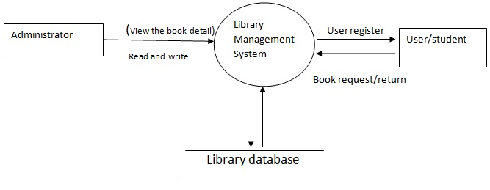

**Level 1 DFD**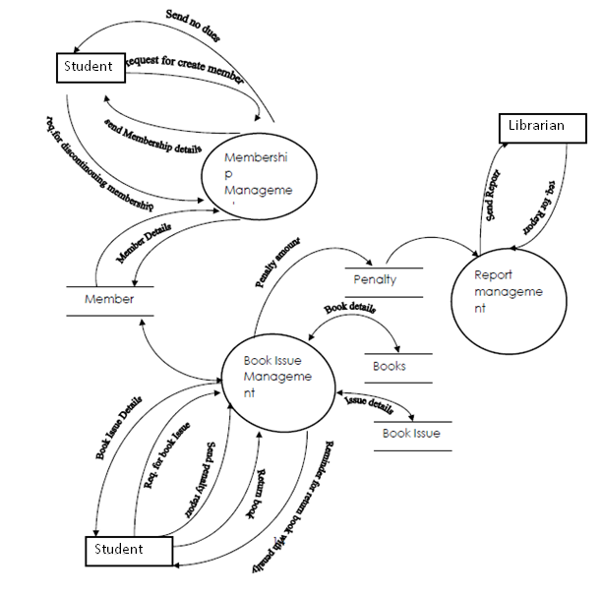

* 1. **Use Case diagram:**

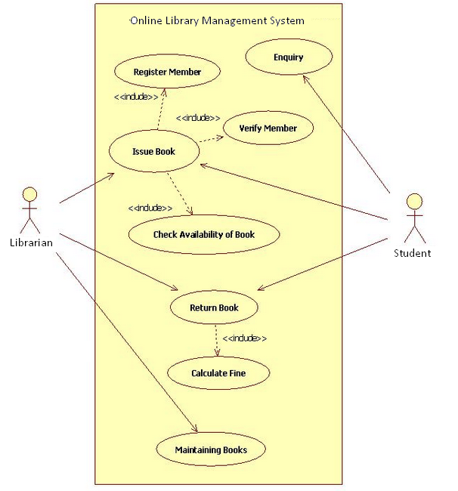

* 1. **Class Diagram:**

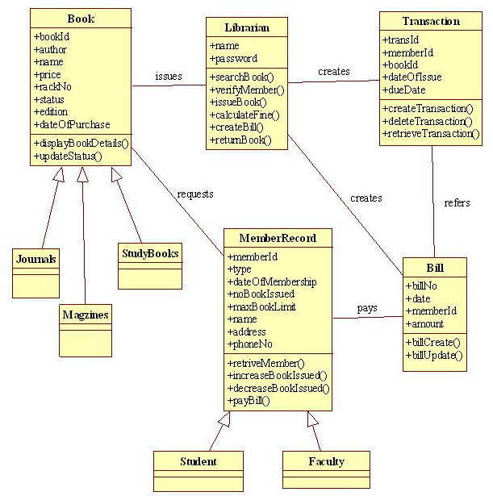

1. **Testing:**

Testing is the process of executing the program with the intent of finding errors and missing operations and also a complete verification to determine whether the objectives are met and the user requirements are satisfied. The ultimate aim is quality assurance.

Tests are carried out and the results are compared with the expected document. In the case of erroneous results, debugging is done. Using detailed testing strategies a test plan is carried out on each module. Thevarious tests performed in “Network Backup System” are unit testing, integration testing and user acceptance

testing.

**5.1 Unit Testing**

The software units in a system are modules and routines that are assembled and integrated to perform a specific function. Unit testing focuses first on modules, independently of one another, to locate errors. Thisenables, to detect errors in coding and logic that are contained within each module. This testing includesentering data and ascertaining if the value matches to the type and size supported by java. The various controlsare tested to ensure that each performs its action as required.

**5.2 Integration Testing**

Data can be lost across any interface, one module can have an adverse effect on another, sub functionswhen combined, may not produce the desired major functions. Integration testing is a systematic testing todiscover errors associated within the interface. The objective is to take unit tested modules and build a programstructure. All the modules are combined and tested as a whole. Here the Server module and Client moduleoptions are integrated and tested. This testing provides the assurance that the application is well integratedfunctional unit with smooth transition of data.

**5.3 User Acceptance Testing**

User acceptance of a system is the key factor for the success of any system. The system under

consideration is tested for user acceptance by constantly keeping in touch with the system users at time of developing and making changes whenever required

1. **Implementation:**

Implementation is the stage in the project where the theoretical design is turned into a working system and is giving confidence on the new system for the users that it will work efficiently and effectively. It involves careful planning, investigation of the current system and its constraints on implementation, design of methods to achieve the change over, an evaluation of change over methods. Apart from planning major task of preparing

the implementation are education and training of users. The implementation process begins with preparing a plan for the implementation of the system. According to this plan, the activities are to be carried out, discussions made regarding the equipment and resources and the additional equipment has to be acquired to implement the new system. In network backup system no additional resources are needed. Implementation is the final and the most important phase. The most critical stage in achieving a successful

new system is giving the users confidence that the new system will work and be effective. The system can be implemented only after thorough testing is done and if it is found to be working according to the specification. This method also offers the greatest security since the old system can take over if the errors are found or inability to handle certain type of transactions while using the new system.

**6.1 User Training:**

After the system is implemented successfully, training of the user is one of the most important subtasks of the developer. For this purpose user manuals are prepared and handled over to the user to operate the developed system. Thus the users are trained to operate the developed system. Both the hardware and software securities are made to run the developed systems successfully in future. In order to put new application

system into use, the following activities were taken care of:

· Preparation of user and system documentation

. Conducting user training with demo and hands on

· Test run for some period to ensure smooth switching over the system

The users are trained to use the newly developed functions. User manuals describing the procedures for

using the functions listed on menu are circulated to all the users. It is confirmed that the system is implemented

up to users need and expectations.

**6.2 Security and Maintenance:**

Maintenance involves the software industry captive, typing up system resources .It means restoring something to its original condition. Maintenance follows conversion to the extend that changes are necessary to maintain satisfactory operations relative to changes in the user’s environment. Maintenance often includes minor enhancements or corrections to problems that surface in the system’s operation. Maintenance is also done based on fixing the problems reported, changing the interface with other software or hardware enhancing

the software. Any system developed should be secured and protected against possible hazards. Security measures are provided to prevent unauthorized access of the database at various levels. An uninterrupted power supply should be so that the power failure or voltage fluctuations will not erase the data in the files. Password protection and simple procedures to prevent the unauthorized access are provided to the users .The system allows the user to enter the system only through proper user name and password

1. **Conclusion & Future Scope:**

This application fits into the current scenario, which is the information age. Modern hostels, to increase their efficiency can use this application with some modifications as per their customized needs. This project “HOSTEL MANAGEMENT SYSTEM” aims at automating all the work being done manually in hostels at present. On completion of this project would expedite the work in all regards. Creating a system to automate the services offered by the hostel, this would be more flexible then their earlier system.

1. **Bibliography:**

* Appendix A: Coding

1. **Home**

<html>

<head>

<div style="border-radius: 25px;background-color:darkblue;color:white;text-align:center;padding:5px;border:3px solid black; background: rgba(54, 54, 200, 0.5)

">

<imgsrc="headerlogo.png" height="42" width="42"/>

<h1>Online Library Management</h1>

</div>

<link rel="stylesheet" href="OLMS.css">

<script>

functioncheckforBlank()

{

if(document.getElementById('UID').value ==""){

alert('UID textbox cannot be left empty !!!');

document.getElementById('UID').style.borderColor="red";

return false;

}

if(document.getElementById('pwd').value ==""){

document.getElementById('alertpwd').innerHTML="Password field is left empty !!";

return false;

}

}

</script>

<body background="library1.jpg">

<section class="container">

<div class="login">

<h1 align="center">Login to System</h1>

<form method="post" action="Login.php" onsubmit="return checkforBlank()">

<p><input type="text" id="UID" name="UID" value="" placeholder="UID"></p>

<p><input type="password" id="pwd" name="pwd" value="" placeholder="Password"></p>

<span id="alertpwd" style="color:red" ></span>

<p class="remember_me">

<label>

<input type="checkbox" name="remember_me" id="remember_me">

Remember me on this computer

</label>

</p>

<p class="submit"><input type="submit" name="commit" value="Login"></p>

</form>

<form method="post" action="SignUp.html">

<p><input type="submit" name="commit" value="SignUp"></p>

</form>

</div>

<div class="login-help">

<p>Forgot your password? <a href="SignUp.html">Click here..!!</a>.</p>

</div>

</section>

</body>

</head>

</html>

1. **Admin**

<html>

<head>

<div style="border-radius: 25px;background-color:darkblue;color:white;text-align:center;padding:5px;border:3px solid black; background: rgba(54, 54, 200, 0.5)

">

<imgsrc="headerlogo.png" height="42" width="42"/>

<h1>Online Library Management</h1>

</div>

<link rel="stylesheet" href="OLMS.css">

<script>

functioncheckforBlank()

{

if(document.getElementById('UID').value ==""){

alert('Username cannot be left empty !!!');

document.getElementById('UID').style.borderColor="red";

return false;

}

if(document.getElementById('pwd').value ==""){

document.getElementById('alertpwd').innerHTML="Password field is left empty !!";

return false;

}

}

</script>

<body background="library1.jpg">

<section class="container">

<div style="width:290px;background: rgba(159,145,107, 0.9)" class="login">

<h1 align="center">Login to System</h1>

<form method="post" action="Login.php" onsubmit="return checkforBlank()">

<p><input type="text" id="UID" name="UID" value="" placeholder="Username"></p>

<p><input type="password" id="pwd" name="pwd" value="" placeholder="Password"></p>

<span id="alertpwd" style="color:red" ></span>

<p class="remember_me">

<label>

<input type="checkbox" name="remember_me" id="remember_me">

Remember me on this computer

</label>

</p>

<p class="submit"><input style="position: relative;top:3px;left:110px"type="submit" name="login" value="Login"></p><p>Forgot your password? <a href="SignUp.html">Click here..!!</a>.</p>

</div>

</section>

</body>

</head>

</html>

1. **SignUp**

<?php

$con=mysqli_connect("localhost","root","","mini_project"); ?>

<?php

if(isset($_POST['submit']))

{

session_start();

$uid=$_POST['UID'];

$email=$_POST['email'];

$sql=$con->query("INSERT INTO student(uid,email) Values('{$UID}','{$email}')");

header('location: OLMS.html');

}

?>

<?php

if ($nameErr = "" & $emailErr = "" & $UIDErr = "")

{

$user="root";

$pass="";

$db="mini_project";

mysqli_select_db($conn,$db);

$sql="INSERT INTO 'student' VALUES ('".$_POST['UID']."','".$blank."','".$blank."','".$blank."','".$blank."','".$_POST['email']."')";

$sql="INSERT INTO 'student' VALUES ('{$})";

$res=mysqli_query($conn,$sql);

header("location:OLMS.html");

mysqli_close($conn);

}

?>

<!DOCTYPE HTML>

<html>

<head>

<link rel="stylesheet" href="OLMS.css">

<style>

.error {color: #FF0000;}

</style>

<div style="border-radius: 25px;background-color:darkblue;color:white;text-align:center;padding:5px;border:3px solid black; background: rgba(54, 54, 200, 0.5)

">

<imgsrc="headerlogo.png" height="42" width="42"/>

<h1>Online Library Management</h1>

</div>

<script>

functionnameCheck() {

var x = document.forms["signup"]["name"].value;

if (!isNaN(x)) {

alert("Name must must not contain numbers");

return false;

}

}

</script>

</head>

<body background="library1.jpg">

<section class="container">

<?php

// define variables and set to empty values

$nameErr = $emailErr = $UIDErr = "";

$name = $email = $UID = "";

if ($_SERVER["REQUEST_METHOD"] == "POST") {

if (empty($_POST["name"])) {

$nameErr = "Name is required";

} else {

$name = test_input($_POST["name"]);

// check if name only contains letters and whitespace

if (!preg_match("/^[a-zA-Z ]*$/",$name)) {

$nameErr = "Only letters and white space allowed";

}

}

if (empty($_POST["email"])) {

$emailErr = "Email is required";

} else {

$email = test_input($_POST["email"]);

// check if e-mail address is well-formed

if (!filter_var($email, FILTER_VALIDATE_EMAIL)) {

$emailErr = "Invalid email format";

}

}

if (empty($_POST["UID"])) {

$UID = "";

} else {

$UID = test_input($_POST["UID"]);

}

}

functiontest_input($data) {

$data = trim($data);

$data = stripslashes($data);

$data = htmlspecialchars($data);

return $data;

}

?>

<div align="center" style="border-radius: 25px;background-color:darkblue;color:white;text-align:center;padding:5px;border:3px solid black; background: rgba(24, 154, 90, 0.7)

">

<h2>Signup</h2>

<p><span class="error">* required field.</span></p>

<form name="signup" method="post" action="<?php echo htmlspecialchars($_SERVER["PHP_SELF"]);?>">

UID:<input type="text" name="UID" required value="<?php echo $UID;?>" pattern="[A-Za-z0-9]{10}" title="UID pattern">

<span class="error">* <?php echo $UIDErr;?></span>

<br><br>

Name: <input type="text" name="name" required value="<?php echo $name;?>" onsubmit="return nameCheck()" title="Name pattern">

<span class="error">* <?php echo $nameErr;?></span>

<br><br>

E-mail: <input type="text" name="email" required value="<?php echo $email;?>">

<span class="error">* <?php echo $emailErr;?></span>

<br><br>

<input type="submit" name="submit" value="Submit">

</form</div>

</section>

</body></html>

1. **SignUp.php**

<?php

$connection = mysql_connect("localhost", "root", ""); // Establishing connection with server..

$db = mysql_select_db("lib", $connection); // Selecting Database.

$uid=$_POST['UID'];

$password= $_POST['pwd']; // Fetching Values from URL.

$name=$_POST['name'];

$email=$_POST['email'];

// Password Encryption, If you like you can also leave sha1.

// Check if e-mail address syntax is valid or not

$email = filter_var($email, FILTER_SANITIZE_EMAIL); // Sanitizing email(Remove unexpected symbol like <,>,?,#,!, etc.)

if (!filter_var($email, FILTER_VALIDATE_EMAIL)){

echo "Invalid Email.......";

}else{

$result = mysql_query("SELECT * FROM registration WHERE email='$email'");

$data = mysql_num_rows($result);

if(($data)==0){

$query = mysql_query("insert into registration(uid, name, email, password) values ('$uid', '$name','$email', '$password')"); // Insert query

if($query){

echo "You have Successfully Registered.....";

echo" To login ";

echo "<a href='OLMS.html'>Click Here..!!!";

}else

{

echo "Error....!!";

}

}else{

echo "This email is already registered, Please try another email...";

}

}

mysql_close ($connection);

?>

1. **Login.php**

<?php

$uid=$_POST['uid'];

$pwd=$_POST['pwd'];

$host="localhost";

$user="root";

$pass="";

$db="lib";

mysql_connect($host,$user,$pass);

mysql_select_db($db);

if(isset($_POST['uid']))

{

$sql="SELECT * FROM registration WHERE uid='$uid' AND password='$pwd'";

$res=mysql_query($sql);

$row=mysql_fetch_assoc($res);

if(mysql_num_rows($res)==1)

{

header('Location:userfetch.php?&uid='.$row['uid']);

}

else

{

header("Location:OLMS.html");

}

}

?>

1. **Userfetch.php**

<html>

<div style="border-radius: 25px;background-color:darkblue;color:white;text-align:center;padding:5px;border:3px solid black; background: rgba(200, 54, 200, 0.5)

">

<img src="headerlogo.png" height="42" width="42"/>

<h1><marquee>Welcome to your Account</marquee></h1>

</div>

<link rel="stylesheet" href="css/OLMS.css">

<body background="library1.jpg">

<div style="height:90px;color:white;border-radius: 15px;background: rgba(54, 178, 200, 0.9)">

<h1><?php include("userfetch_Includer.php"); echo " ".$rowName['name'];?></h1>

</div>

<form method='get' action='OLMS.html'><input style='position: relative;top: -63px;left: 1310px' type='submit' value='Logout'>

</form>

<div align='center'style='width:400px;color:white;background: rgba(160, 203, 192, 0.8)'>

<fieldset>

<legend>

<h1 style='color:white'>Your Info.</h1>

</legend>

<table border='1' style='color:white'>

<tr><td><h3>bookheld</td></h3><td><h3><?php include("userfetch_Includer.php"); echo $row['bookname']; ?></h3></td></tr>

<tr><td><h3>Fine</td><td><h3><?php include("userfetch_Includer.php"); echo $row1['fine']; ?></h3></td></tr>

<tr><td><h3>bookstatus</td><td><h3><?php include("userfetch_Includer.php") ;echo $row2['bookstatus']; ?></h3></td></tr>

</table>

</div>

</fieldset>

</body>

</html>

1. **Userfetch_Includer.php**

<?php

$host="localhost";

$user="root";

$pass="";

$db="lib";

mysql_connect($host,$user,$pass);

mysql_select_db($db);

//$name=$_GET['name'];

$uid=$_GET['uid'];

$name="SELECT * FROM registration WHERE uid='".$uid."'";

$bookname="SELECT bookname FROM bookrecords WHERE uid='".$uid."'";

$penalty="SELECT fine FROM bookrecords WHERE uid='".$uid."'";

$bookstatus="SELECT bookstatus FROM bookrecords WHERE uid='".$uid."'";

$resName=mysql_query($name);

$rowName=mysql_fetch_assoc($resName);

$res=mysql_query($bookname);

$row=mysql_fetch_assoc($res);

$res1=mysql_query($penalty);

$row1=mysql_fetch_assoc($res1);

$res2=mysql_query($bookstatus);

$row2=mysql_fetch_assoc($res2);

?>

1. **Admin1.php**

<html>

<div style="border-radius: 25px;background-color:darkblue;color:white;text-align:center;padding:5px;border:3px solid black; background: rgba(200, 54, 200, 0.5)

">

<img src="headerlogo.png" height="42" width="42"/>

<h1><marquee>Admin Portal</marquee></h1>

</div>

<link rel="stylesheet" href="css/OLMS.css">

<body background="library1.jpg">

<div style="height:90px;color:white;border-radius: 15px;background: rgba(54, 178, 200, 0.9)">

<h1 style="position:absolute;float:left">Welcome<?php $name=" ".$_GET['name'];echo $name;?></h1>

<form method='get' action='OLMS.html'><input style='position: relative;left:1280px;top:30px' type='submit' value='Logout'>

</form>

<div style="height:50px"></div>

<div align='left' style="border-radius:15px;height:291px;width:200px;border:3px solid #6D343D;background: rgba(151,151,26, 0.8)">

<div align='center'style="border:3px solid #6D343D" ><h2><a href="Admin1.php">Home</a></h2></div>

<div align='center'style="border:3px solid #6D343D" ><h2><a href="updaterecords.php">UpdateRecords</a></h2></div>

<div align='center'style="border:3px solid #6D343D" ><h2><a href="records.php">Records</a></h2></div>

<div align='center'style="border:3px solid #6D343D" ><h2><a href="Fine.php">Fine</a></h2></div>

</div>

</div>

</body>

</html>

1. **UpdateRecords.php**

<html>

<div style="border-radius: 25px;background-color:darkblue;color:white;text-align:center;padding:5px;border:3px solid black; background: rgba(200, 54, 200, 0.5)

">

<img src="headerlogo.png" height="42" width="42"/>

<h1><marquee>Admin Portal</marquee></h1>

</div>

<link rel="stylesheet" href="css/OLMS.css">

<body background="library1.jpg">

<div style="height:90px;color:white;border-radius: 15px;background: rgba(54, 178, 200, 0.9)">

<h1 style="position:absolute;float:left">Welcome<?php $name=" ".$_GET['name'];echo $name;?></h1>

<form method='get' action='OLMS.html'><input style='position: relative;left:1280px;top:30px' type='submit' value='Logout'>

</form>

<div style="height:50px"></div>

<div align='left' style="border-radius:15px;height:291px;width:200px;border:3px solid #6D343D;background: rgba(151,151,26, 0.8)">

<div align='center'style="border:3px solid #6D343D" ><h2><a href="Admin1.php">Home</a></h2></div>

<div align='center'style="border:3px solid #6D343D" ><h2><a href="updaterecords.php">UpdateRecords</a></h2></div>

<div align='center'style="border:3px solid #6D343D" ><h2><a href="records.php">Records</a></h2></div>

<div align='center'style="border:3px solid #6D343D" ><h2><a href="Fine.php">Fine</a></h2></div>

</div>

</div>

</body>

</html>

1. **Records.php**

<html>

<div style="border-radius: 25px;background-color:darkblue;color:white;text-align:center;padding:5px;border:3px solid black; background: rgba(200, 54, 200, 0.5)

">

<img src="headerlogo.png" height="42" width="42"/>

<h1><marquee>Admin Portal</marquee></h1>

</div>

<link rel="stylesheet" href="css/OLMS.css">

<body background="library1.jpg">

<div style="float:right;width:300px;height:90px;border-radius: 15px;background: rgba(54, 178, 200, 0.9)"></div>

<form method='get' action='OLMS.html'><input style='position: relative;left:1280px;top:30px' type='submit' value='Logout'>

</form>

<div style="height:50px"></div>

<div align='left' style="border-radius:15px;height:291px;width:200px;border:3px solid #6D343D;background: rgba(151,151,26, 0.8)">

<div align='center'style="border:3px solid #6D343D" ><h2><a href="Admin1.php">Home</a></h2></div>

<div align='center'style="border:3px solid #6D343D" ><h2><a href="updaterecords.php">UpdateRecords</a></h2></div>

<div align='center'style="border:3px solid #6D343D" ><h2><a href="records.php">Records</a></h2></div>

<div align='center'style="border:3px solid #6D343D" ><h2><a href="Fine.php">Fine</a></h2></div>

</div>

<span style="display:block; margin-top:-230px;margin-left:300px">

<table style="position:relative "align="left"width="600" border="1" cellpadding"1" cellspacing="1">

<tr style="background-color: #A7C942">

<th>UID</th>

<th>Name</th>

<th>Email</th>

<th>Password</th>

</tr>

<?php

include("adminfetch_Includer.php");

$sql="SELECT * FROM registration";

$res=mysql_query($sql);

while($row=mysql_fetch_assoc($res))

{

echo "<tr style='background-color:#EAF2D3'>";

echo "<td>".$row['uid']."</td>";

echo "<td><a href='userfetchthroughadmin.php?&uid=".$row['uid']."'>".$row['name']."</a></td>";

echo "<td>".$row['email']."</td>";

echo "<td>".$row['password']."</td>";

echo "</tr>";

}

?>

</table>

</span>

</body>

</html>

</html>

1. **Fine.php**

<html>

<div style="border-radius: 25px;background-color:darkblue;color:white;text-align:center;padding:5px;border:3px solid black; background: rgba(200, 54, 200, 0.5)

">

<img src="headerlogo.png" height="42" width="42"/>

<h1><marquee>Admin Portal</marquee></h1>

</div>

<link rel="stylesheet" href="css/OLMS.css">

<body background="library1.jpg">

<div style="float:right;width:300px;height:90px;border-radius: 15px;background: rgba(54, 178, 200, 0.9)"></div>

<form method='get' action='OLMS.html'><input style='position: relative;left:1280px;top:30px' type='submit' value='Logout'>

</form>

<div style="height:50px"></div>

<div align='left' style="border-radius:15px;height:291px;width:200px;border:3px solid #6D343D;background: rgba(151,151,26, 0.8)">

<div align='center'style="border:3px solid #6D343D" ><h2><a href="Admin1.php">Home</a></h2></div>

<div align='center'style="border:3px solid #6D343D" ><h2><a href="updaterecords.php">UpdateRecords</a></h2></div>

<div align='center'style="border:3px solid #6D343D" ><h2><a href="records.php">Records</a></h2></div>

<div align='center'style="border:3px solid #6D343D" ><h2><a href="Fine.php">Fine</a></h2></div>

</div>

<div align="center" style="background: rgba(54, 178, 200, 0.9);width:250px;display:block;margin-top:-260px;margin-left:280px;margin-right:200px">

<form method="get "action="calcfine.php">

<h3>Enter UID:</h3><p><input type="text" id="uid" name="uid" value="" placeholder="UID"></p>

<h3>Enter Amount:</h3><p><input type="text" id="amt" name="amt" value="" placeholder="amount"></p>

<p class="submit"><input style="position: relative" type="submit" value="Submit"></p>

</form>

</div>

</body>

</html>

1. **userfetchthroughadmin.php**

html>

<div style="border-radius: 25px;background-color:darkblue;color:white;text-align:center;padding:5px;border:3px solid black; background: rgba(200, 54, 200, 0.5)

">

<img src="headerlogo.png" height="42" width="42"/>

<h1><?php include("userfetch_Includer.php"); echo $rowName['name']."'s "?>Account</h1>

</div>

<link rel="stylesheet" href="css/OLMS.css">

<body background="library1.jpg">

<!--<div style="height:90px;color:white;border-radius: 15px;background: rgba(54, 178, 200, 0.9)">

<h1><?php include("userfetch_Includer.php"); echo " ".$rowName['name'];?></h1>

</div>

<form method='get' action='OLMS.html'><input style='position: relative;top: -63px;left: 1310px' type='submit' value='Logout'>

</form>-->

<div align='center'style='width:400px;color:white;background: rgba(160, 203, 192, 0.8)'>

<fieldset>

<legend>

<h1 style='color:white'>Your Info.</h1>

</legend>

<table border='1' style='color:white'>

<tr><td><h3>Bookheld</td></h3><td><h3><?php include("userfetch_Includer.php"); echo $row['bookname']; ?></h3></td></tr>

<tr><td><h3>Fine</td><td><h3><?php include("userfetch_Includer.php"); echo $row1['fine']; ?></h3></td></tr>

<tr><td><h3>Bookstatus</td><td><h3><?php include("userfetch_Includer.php") ;echo $row2['bookstatus']; ?></h3></td></tr>

</table>

</div>

</fieldset>

</body>

</html>

1. **Help.php**

<?php

$host="localhost";

$user="root";

$pass="";

$db="lib";

mysql_connect($host,$user,$pass);

mysql_select_db($db);

$uid=$_GET['uid'];

$email=$_GET['email'];

$sql="SELECT * FROM registration WHERE uid='$uid' AND email='$email'";

$res=mysql_query($sql);

$row=mysql_fetch_assoc($res);

echo "Your Password".$row['password'];

?>

1. **Recovery.html**

<html>

<head>

<body background="library1.jpg">

<div style="border-radius: 25px;background-color:darkblue;color:white;text-align:center;padding:5px;border:3px solid black; background: rgba(54, 54, 200, 0.5)

">

<img src="headerlogo.png" height="42" width="42"/>

<h1>Recovery Form</h1>

</div>

<link rel="stylesheet" href="css/OLMS.css">

<section class="container">

<form action="Help.php">

<div align="center" style="width:290px;background: rgba(107, 153, 159, 0.9)" >

Enter Your UID <input type="text" id="uid" name="uid" value="" placeholder="UID"></p>

Enter Your Email <input type="text" id="email" name="email" value="" placeholder="Email"></p>

<input type="submit" id="login" name="login" value="Submit">

</form>

</div>

</section>

</body>

</html>

1. **add.php**

<?php

$connection = mysql_connect("localhost", "root", ""); // Establishing connection with server..

$db = mysql_select_db("lib", $connection); // Selecting Database.

$uid=$_GET['uid'];

$password= $_GET['pwd']; // Fetching Values from URL.

$name=$_GET['name'];

$email=$_GET['email'];

// Password Encryption, If you like you can also leave sha1.

// Check if e-mail address syntax is valid or not

$email = filter_var($email, FILTER_SANITIZE_EMAIL); // Sanitizing email(Remove unexpected symbol like <,>,?,#,!, etc.)

if (!filter_var($email, FILTER_VALIDATE_EMAIL)){

echo "Invalid Email.......";

}else{

$result = mysql_query("SELECT * FROM registration WHERE email='$email'");

$data = mysql_num_rows($result);

if(($data)==0){

$query = mysql_query("insert into registration(uid, name, email, password) values ('$uid', '$name','$email', '$password')"); // Insert query

if($query){

echo "You have Successfully Added an User.....";

}else

{

echo "Error....!!";

}

}else{

echo "This email is already registered, Please try another email...";

}

}

mysql_close ($connection);

1. **delete.php**

<?php

$connection = mysql_connect("localhost", "root", ""); // Establishing connection with server..

$db = mysql_select_db("lib", $connection); // Selecting Database.

$uid=$_GET['uid'];

$query = mysql_query("DELETE FROM registration WHERE uid='$uid'"); // Delete query

if($query){

echo "You have Successfully deleted a record....";

}

else

{

echo "Error....!!";

}

mysql_close ($connection);

?>

1. **calcfine.php**

<?php

$connection = mysql_connect("localhost", "root", ""); // Establishing connection with server..

$db = mysql_select_db("lib", $connection); // Selecting Database.

$uid=$_GET['uid'];

$query = mysql_query("DELETE FROM registration WHERE uid='$uid'"); // Delete query

if($query){

echo "You have Successfully deleted a record....";

}

else

{

echo "Error....!!";

}

mysql_close ($connection);

?>

1. **OLMS.css**

.container {

margin: 80px auto;

width: 640px;

}

.login {

position: relative;

margin: 0 auto;

padding: 20px 20px 20px;

width: 310px;

background: white;

border-radius: 3px;

@include box-shadow(0 0 200px rgba(white, .5), 0 1px 2px rgba(black, .3));

&:before {

content: '';

position: absolute;

top: -8px; right: -8px; bottom: -8px; left: -8px;

z-index: -1;

background: rgba(black, .08);

border-radius: 4px;

}

h1 {

margin: -20px -20px 21px;

line-height: 40px;

font-size: 15px;

font-weight: bold;

color: #555;

text-align: center;

text-shadow: 0 1px white;

background: #f3f3f3;

border-bottom: 1px solid #cfcfcf;

border-radius: 3px 3px 0 0;

}

p { margin: 20px 0 0; }

p:first-child { margin-top: 0; }

input[type=text], input[type=password] { width: 278px; }

p.remember_me {

float: left;

line-height: 31px;

label {

font-size: 12px;

color: #777;

cursor: pointer;

}

input {

position: relative;

bottom: 1px;

margin-right: 4px;

vertical-align: middle;

}

}

p.submit { text-align: right; }

}

.login-help {

position: relative;

margin: 0 auto;

padding: 20px 20px 20px;

width: 310px;

background: white;

border-radius: 3px;

}

input {

font-family: 'Lucida Grande', Tahoma, Verdana, sans-serif;

font-size: 14px;

}

input[type=text], input[type=password] {

margin: 5px;

padding: 0 10px;

width: 200px;

height: 34px;

color: #404040;

background: white;

border: 1px solid;

border-color: #c4c4c4 #d1d1d1 #d4d4d4;

border-radius: 2px;

outline: 5px solid #eff4f7;

-moz-outline-radius: 3px;

&:focus {

border-color: #7dc9e2;

outline-color: #dceefc;

outline-offset: 0;

}

}

input[type=submit] {

padding: 0 18px;

height: 29px;

font-size: 12px;

font-weight: bold;

color: #527881;

text-shadow: 0 1px #e3f1f1;

background: #cde5ef;

border: 1px solid;

border-color: #b4ccce #b3c0c8 #9eb9c2;

border-radius: 16px;

outline: 0;

* Appendix B: Output

1. **Home**

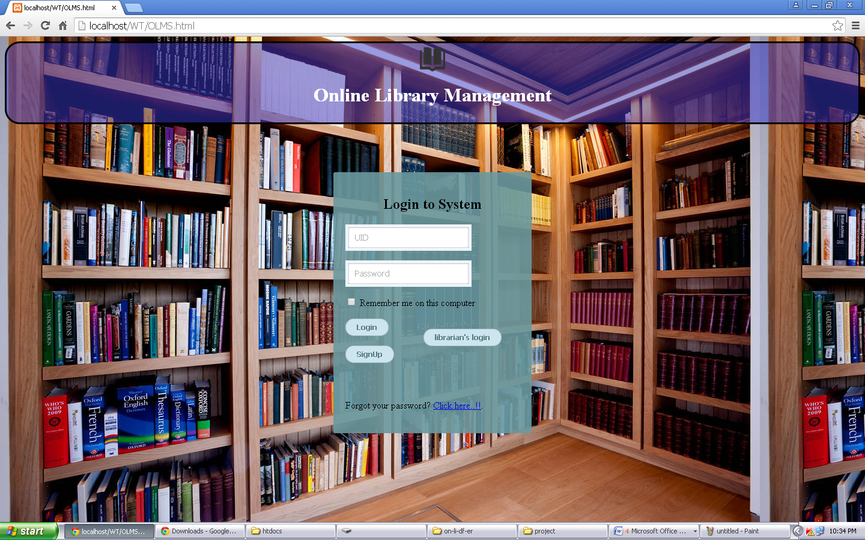

1. **AdminLogin**

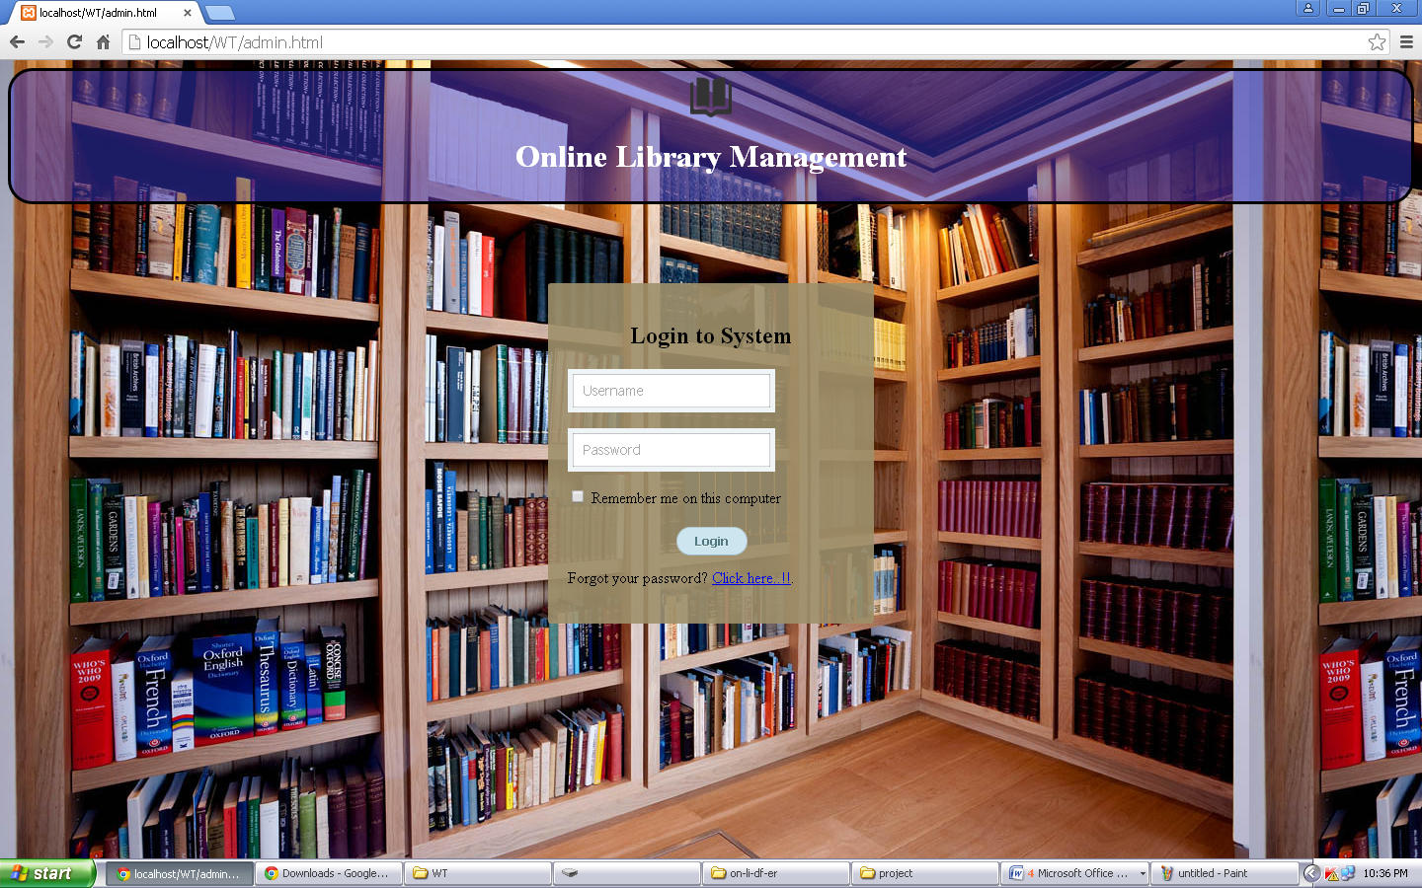

1. **SignUp**

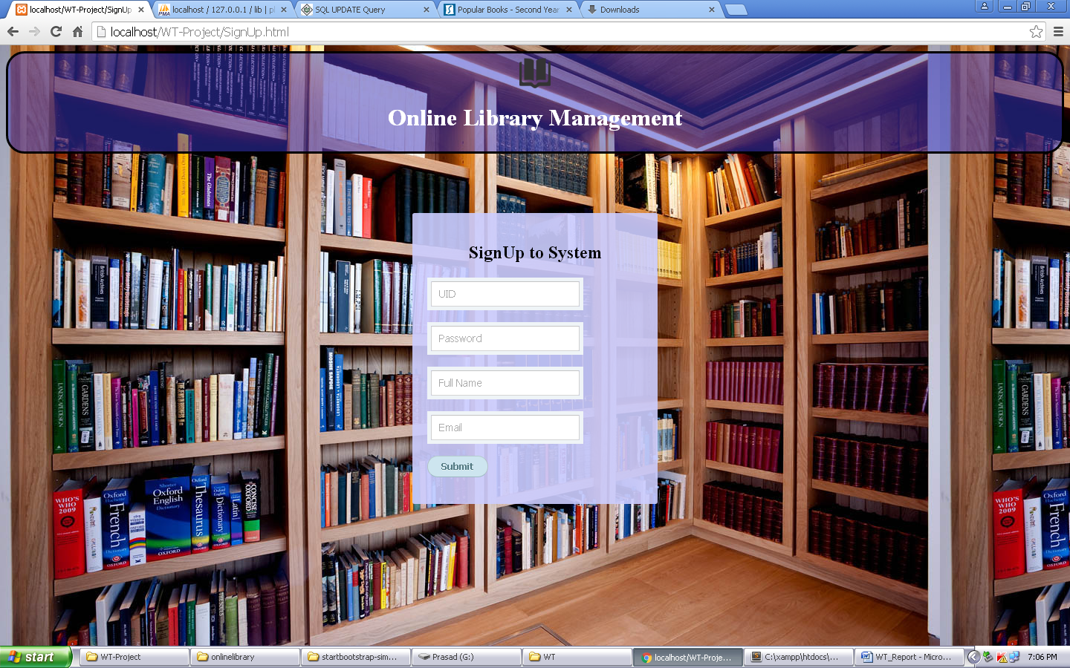

1. **AdminPage**

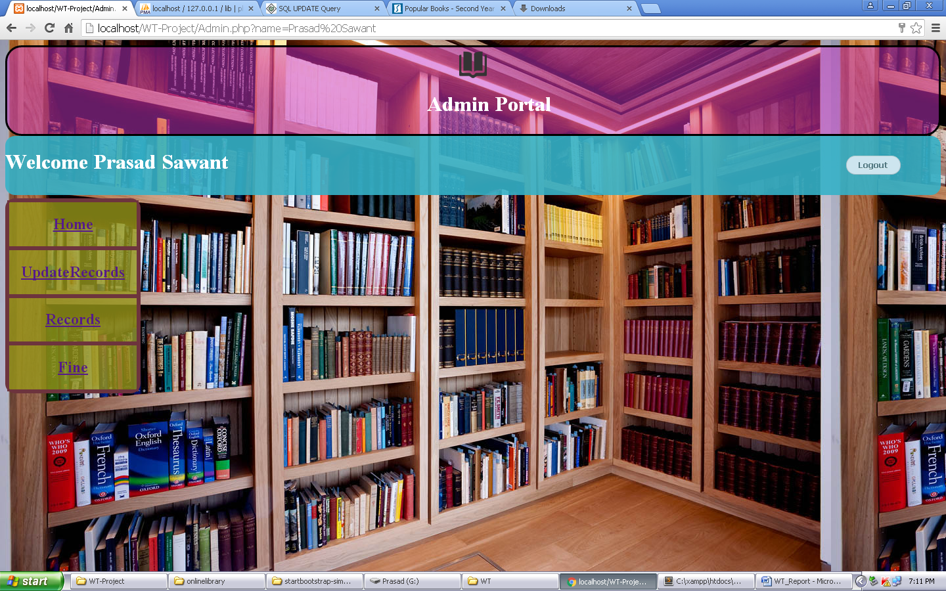

1. **UpdateRecords**

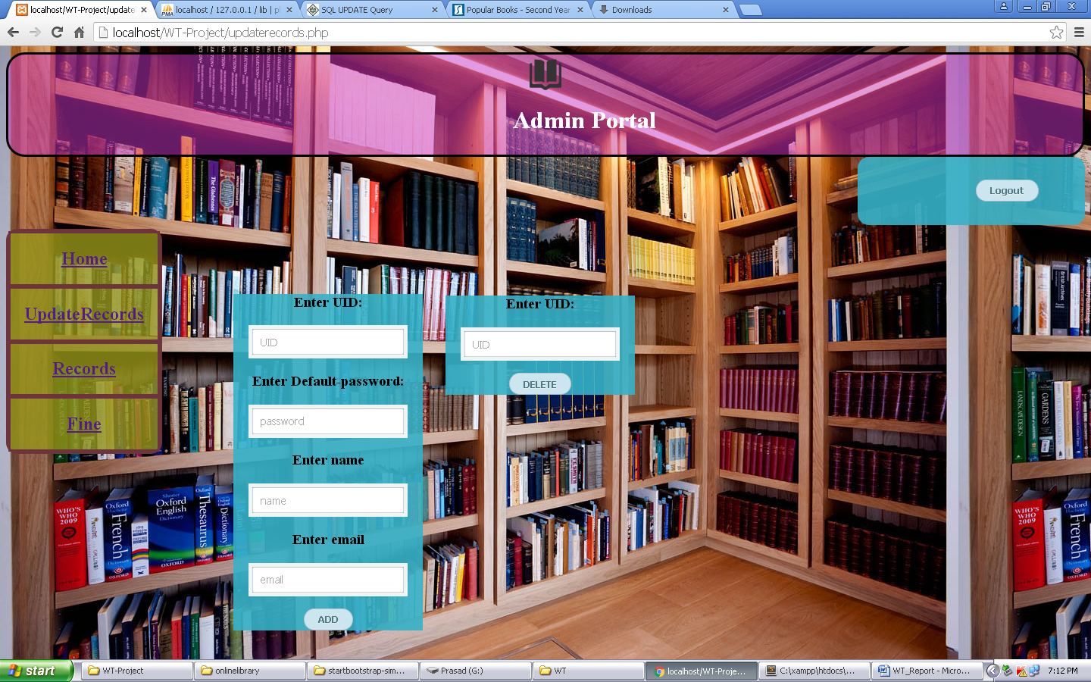

1. **ViewRecords**

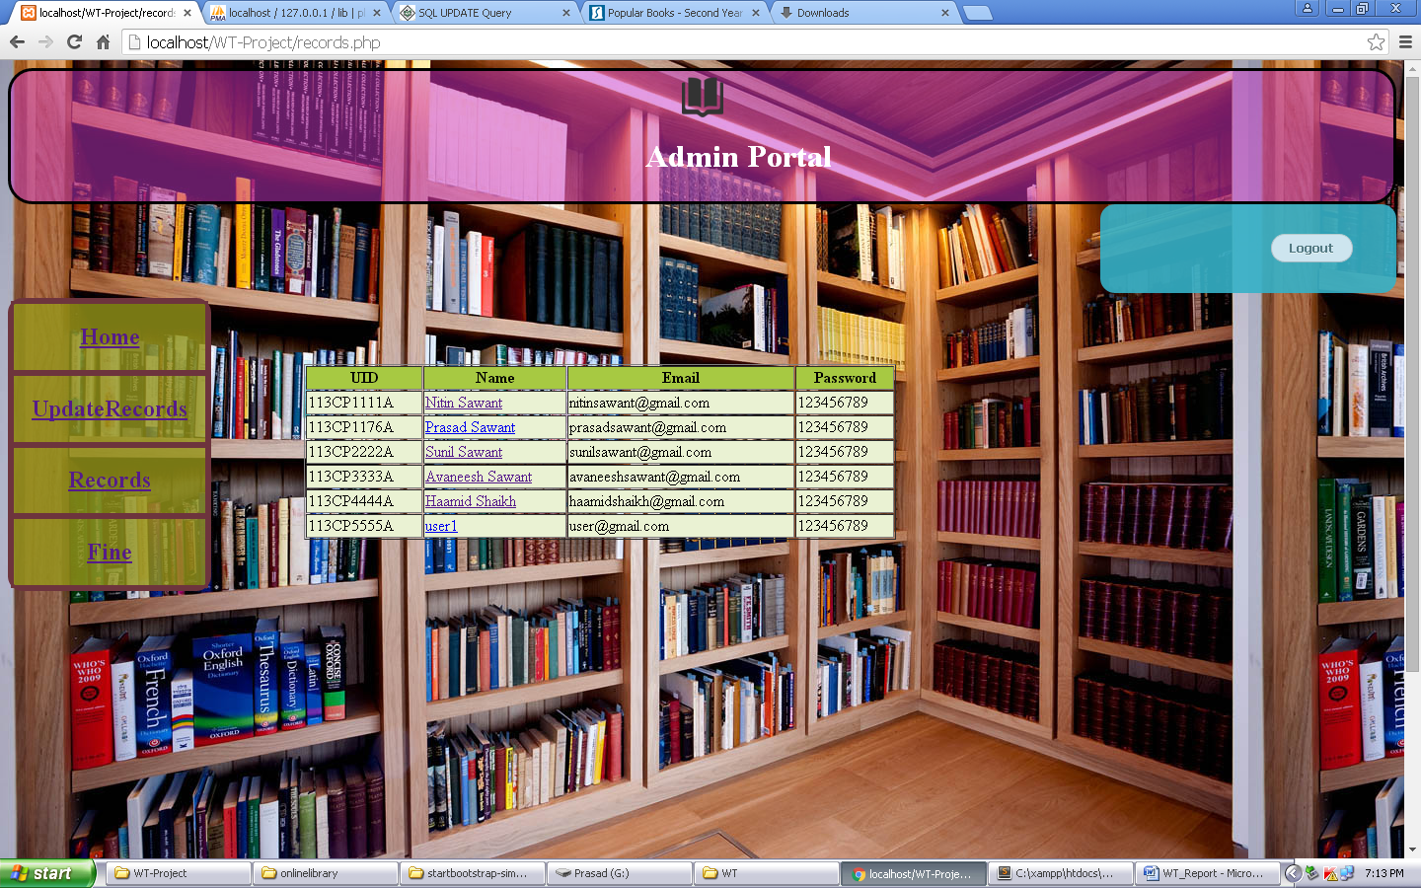

1. **Fine**

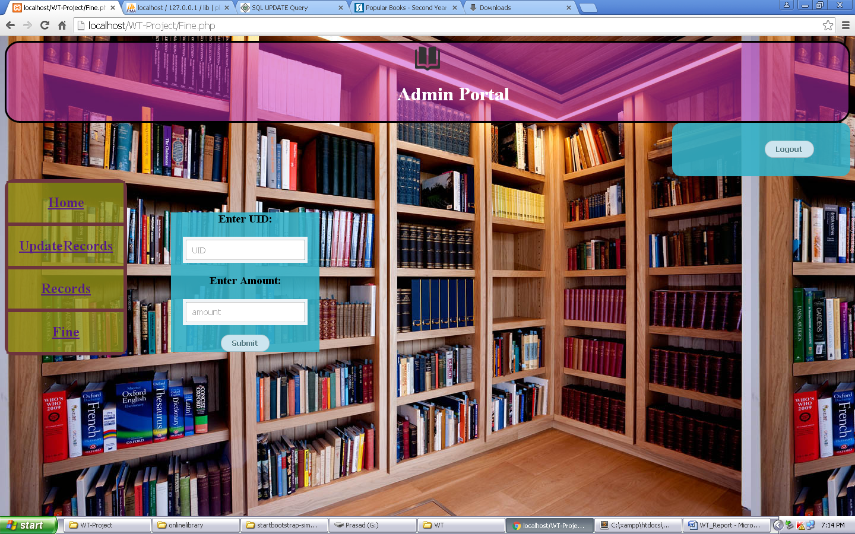

1. **RecoveryForm**

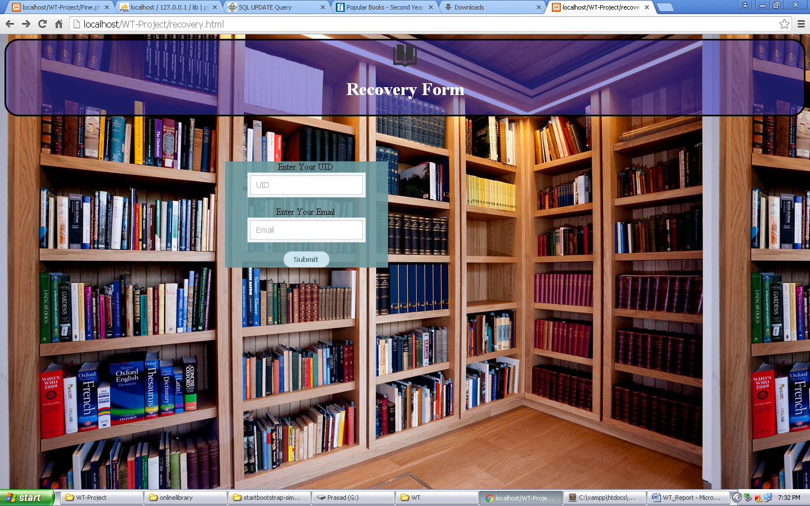

1. **Userpage**

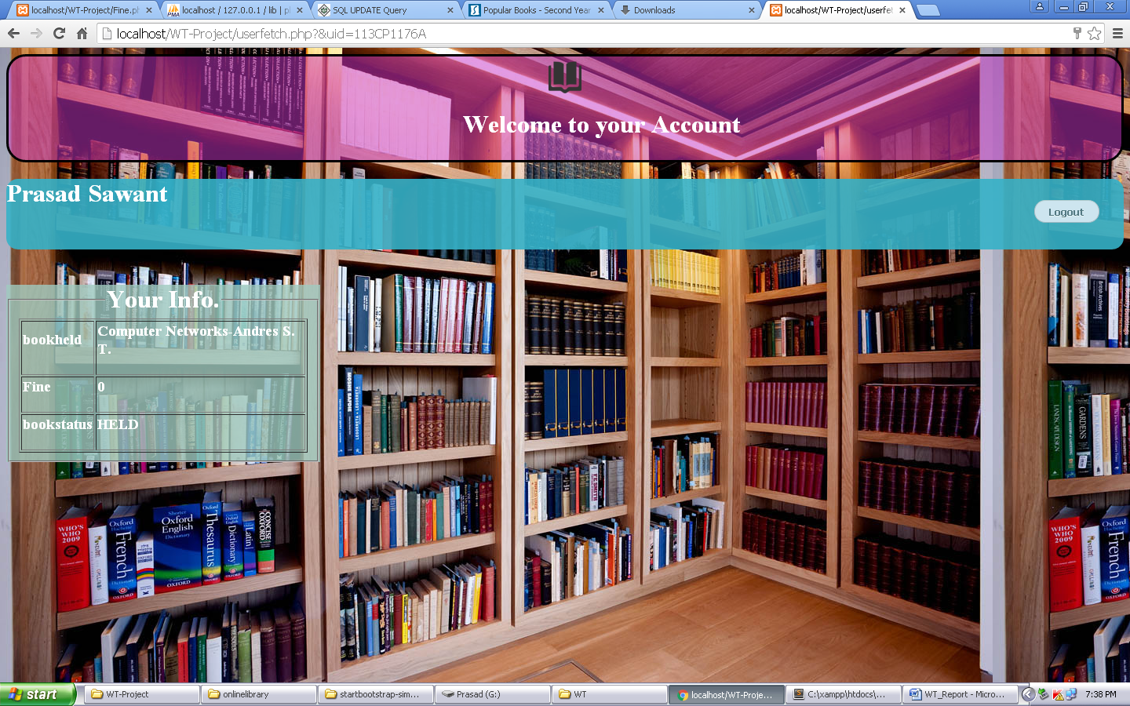

* Appendix C: Abbreviations

1. XML:EXtensible Markup Language
2. PHP: Hypertext Preprocessor
3. CSS: Cascading Stylesheet
4. JS: Java Script

* Appendix D: List of Tables

1. **Database Table**

* LIBRARY DATABASE

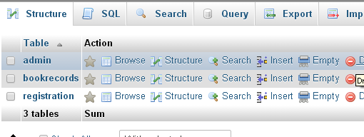

* LIBRARIAN TABLE IN DATABASE

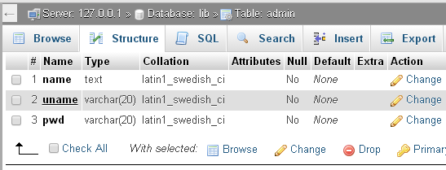

* BOOK TABLE IN DATABASE

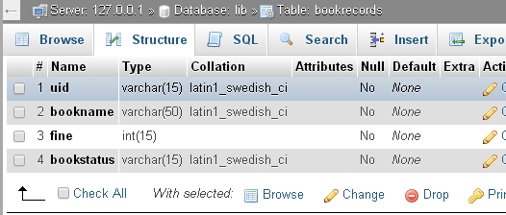

* STUDENT TABLE IN DATABASE

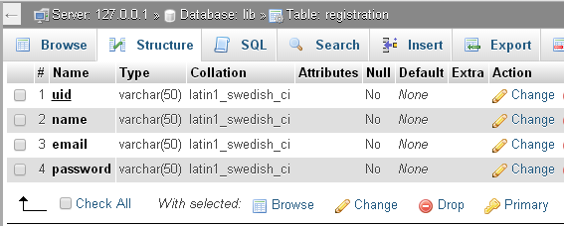

* Appendix E: List of Figures

1. **Data Flow Diagram**
2. **Use Case Diagram**
3. **Class Diagram**